Improving MR Spectroscopy in the liver with a small number of averages by accurate voxel placement
Petronella Samuels¹, Ernesta Meintjes ^{1,2}, and Ali Alhamud ^{1,2}
¹Cape Universities Body Imaging Center, Department of Human Biology, University of Cape Town, Cape Town, South Africa; ²Division of Biomedical Engineering, University of Cape Town, Cape Town, South Africa

Background: Although it is normal for the liver to contain some fat, increased intrahepatic fat, primarily as triglycerides, is associated with insulin resistance (Hwang et al., 2007) and excessive fat accumulation may eventually lead to liver cirrhosis (loss of liver cells) (Della Corte et al., 2015). ¹H MRS is considered the gold standard for quantification of hepatic fat content, allowing each triglyceride moiety to be uniquely identified. To obtain a good spectrum, one should position the voxel in a location where there is no water, bone or air. However, the liver contains large vessels and bile ducts, which makes voxel placement difficult. Furthermore, respiratory motion can cause voxel displacement during lengthy MRS acquisition. In a study conducted by Qayyum (2009), spectra acquired with free breathing using 128 averages yielded optimal SNR. This amounts to a scan time of approximately 11 minutes. To date, an optimal MRS protocol for accurate liver fat quantification has not been established. In this work, we investigate the quality of MRS data acquired using navigated MRS for two different voxel placements, both avoiding vessels and bile ducts, as well as different scan durations (i.e. number of averages).
Teaching points: Three healthy participants (mean age 37 y; weight 100kg), were scanned on a 3T Skyra (Siemens, Germany Erlangen). Subjects were in the feet-first supine position. A large field-of-view 18-channel flex coil was placed over the abdomen and used simultaneously with the 32-channel spine array coil. Acquisitions were performed using two sequences: T1 volume interpolated breath-hold GRE (T1-VIBE) to assess the anatomy of the liver; and free breathing single voxel navigated MRS using a point-resolved spectroscopy (PRESS) sequence with TR/TE = 3000/33 ms, voxel size = 20x20x20 mm³. MRS data were acquired for 2 different voxel placements in the liver. The first voxel was placed in segment 7, approximately 10 mm from the periphery of the liver avoiding vessels and bile ducts. The second location was in segment 8, also avoiding vasculature and ducts. A navigator with acceptance window of ±2 mm was placed on the diaphragm to reduce the influence of respiratory motion. Acquisitions were repeated for 20, 30, 40, 50 and 60 averages. The scan times for these acquisitions were 2:20, 3:10, 4:00, 4:50 and 5:40 minutes respectively. Before each acquisition, manual shimming was performed to ensure full width half maximum (FWHM) shim less than 50 Hz. The average FWHM values for segment 7 and 8 were 39.9Hz and 47.7Hz respectively. Metabolite levels were calculated for middle chain methylene (-CH2-, 1.3 ppm) and methyl (-CH3, 0.9 ppm) groups, as well as glycogen (3.5-3.9 ppm), using LCModel. Two-sided p values less than 0.05 were considered to indicate statistically significant differences.
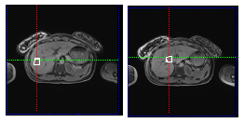
Figure1: Voxel placement in two different regions in the liver (segment 7 to the left and segment 8 to the right).
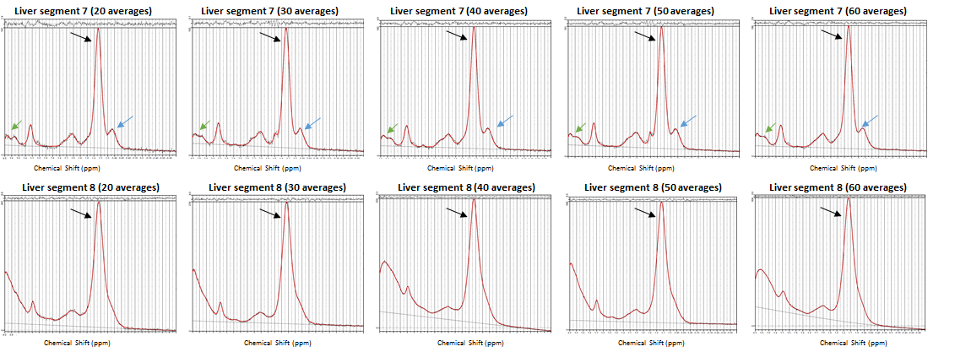
Figure 2: Comparison of MRS spectral quality in one subject for different numbers of averages and different voxel locations (top segment 7; bottom segment 8). The middle chain methylene (1.3 ppm; black) and methyl (0.9 ppm; blue) and glycogen (3.5-3.9 ppm; green) peaks are indicated with arrows.
Figure 1 shows the MRS voxel placement in two different regions in the liver. For one subject, the quality of MRS spectra between the two locations and for different numbers of averages is compared in Figure 2. Table 1 presents, for each subject and each voxel placement, metabolite concentrations (mean ± sd) averaged across acquisitions in the same region with different numbers of averages.
Summary This study demonstrates the importance of voxel placement in the liver. Specifically, positioning the voxel in segment 7 of the liver produces better quality hepatic MRS spectra, irrespective of number of averages, with the middle chain methylene (-CH2-, 1.3 ppm) and methyl (-CH3, 0.9 ppm) groups well separated (Figure 2). For all subjects, mean metabolite levels from spectra acquired in segment 7 with different numbers of averages demonstrate lower standard deviations, as well as lower FWHM compared to spectra acquired in segment 8 (all p’s < 0.01).
Table 1: Mean and standard deviation (mean ± SD) of metabolite levels, averaged over acquisitions with different numbers of averages (20, 30, 40, 50 and 60), for each subject in segments 7 and 8, respectively.
Metabolite  (chemical shift) | Liver Segment | Subject 1  (mean ± SD) | Subject 2  (mean ± SD) | Subject 3  (mean ± SD)
Lipid  (1.3 ppm) | 7  8 | 0.777 ± 0.003  0.782 ± 0.01 | 0.824 ± 0.010  0.8306 ± 0.030 | 0.821 ± 0.018  0.701 ± 0.136
Lipid  (0.9 ppm) | 7  8 | 0.223 ± 0.003**  0.145 ± 0.033 | 0.138 ± 0.005  0.129 ± 0.022 | 0.128 ± 0.012  0.177 ± 0.128
Glycogen  (3.5-3.9 ppm) | 7  8 | 0.164 ± 0.019**  0.028 ± 0.058 | 0.099 ± 0.007***  0.128 ± 0.022 | 0.110 ± 0.012  0.157 ± 0.112
FWHM (Hz) | 7  8 | 0.188 ± 0.003***  0.226 ± 0.004 | 0.222 ± 0.004***  0.317 ± 0.009 | 0.224 ± 0.012**  0.477 ± 0.120
*p<0.05; **p<0.01; ***p<0.001.
In conclusion, placing the MRS voxel at least 10mm from the periphery of the liver yields superior quality MRS data with low FWHM and methyl peaks clearly separated.

References: 1. Hwang, J., et al. Increased intrahepatic triglyceride is associated with peripheral insulin resistance: in vivo MR imaging and spectroscopy studies. The American Journal of Physiology and Endocrinology. 2007; 293: 1663-1669; 2. Della Corte, C., et al. Non-alcoholic fatty pancreas disease and non-alcoholic fatty liver disease: more than ectopic fat. Clinical Endocrinology. 2015; 83(5):656-662; 3. Qayyum, A. MR Spectroscopy of the Liver: Principles and Clinical Applications. RSNA: Radiographics. 2009; 28(6)

