**Examining the effects of SMS and GRAPPA acceleration on resting state fMRI signal quality**

Ingrid Op’t Hof1, Ernesta M Meintjes1,2,Marcin Jankiewicz1,2

1Cape Universities Body Imaging Center, Department of Human Biology, University of Cape town, South Africa;2Division of Biomedical Engineering, Department of Human Biology, University of Cape Town, South Africa.

**Background**

Functional MRI (fMRI) measures signal changes over time and as such is very sensitive to signal drift and motion artifacts. Errors in individual measurements limit our ability to detect meaningful activations. While signal to-noise ratio (SNR) is typically used to assess the quality of structural MRI data, temporal SNR (tSNR) is used for fMRI data where signal time courses are of interest. SNR of an image is the ratio of the mean signal intensity across all voxels and its standard deviation.1 In comparison, tSNR is a measure of the amount of signal present in the data across time. Recently, simultaneous multi-slice imaging (SMS) has been introduced to increase temporal efficiency enabling either higher spatial or temporal resolutions (or a combination of both) in fMRI studies.2 Parallel imaging using GRAPPA is an alternative acceleration technique based on undersampling of k-space. In this work we examine the effects of SMS and GRAPPA acceleration on tSNR in resting state fMRI (RS-fMRI) data. To ensure that any changes in signal quality were attributable only to acceleration, spatial and temporal resolutions were kept constant for all acquisitions.

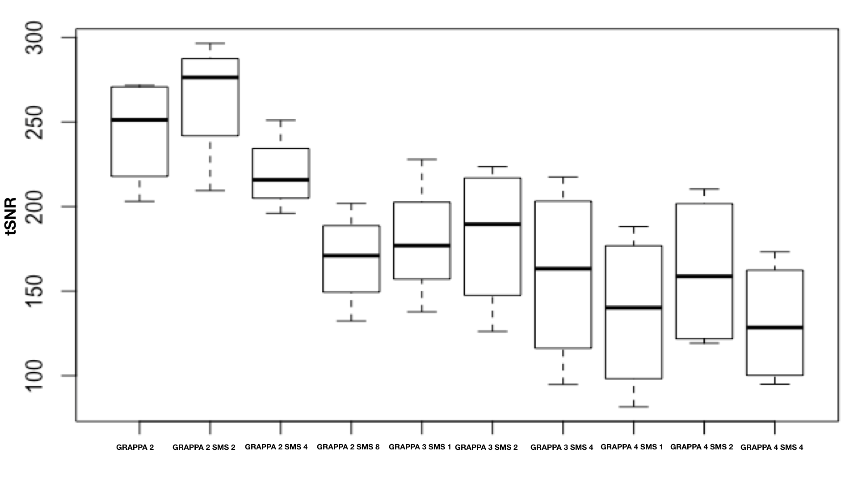 Figure 1: Whole-brain mean tSNR averaged over four subjects for different combinations of GRAPPA and SMS factors.

**Methods**

Four healthy volunteers (aged between 20 and 40) were scanned on a 3T Skyra (Siemens, Erlangen, Germany) using a 2D SMS gradient echo EPI sequence. We used a constant TR/TE 2000/30ms, 33 slices, voxel size 3x3x4mm3, 180 measurements. Data were acquired for GRAPPA factors 2, 3 and 4, each for SMS factors 1 (no acceleration), 2 and 4, and SMS 8 for GRAPPA 2.

Image processing was performed in Matlab. First, for each subject, a voxelwise tSNR value was computed for every voxel by taking the ratio of the mean and standard deviation of the signal across time. Voxelwise tSNR values were then averaged across the whole brain to obtain a mean tSNR for each subject.

**Results**

Figure1 shows whole-brain mean tSNR values, averaged over the 4 subjects, as a function of GRAPPA and SMS factors. In figure 2 we use a color map to show voxelwise tSNR values across the brain in one subject for different GRAPPA and SMS acceleration factors. Only voxels that have a tSNR value greater than the whole-brain average for the GRAPPA 2 acquisition are shown in color. It is evident from the images that fewer voxels meet this criterion at higher acceleration factors.

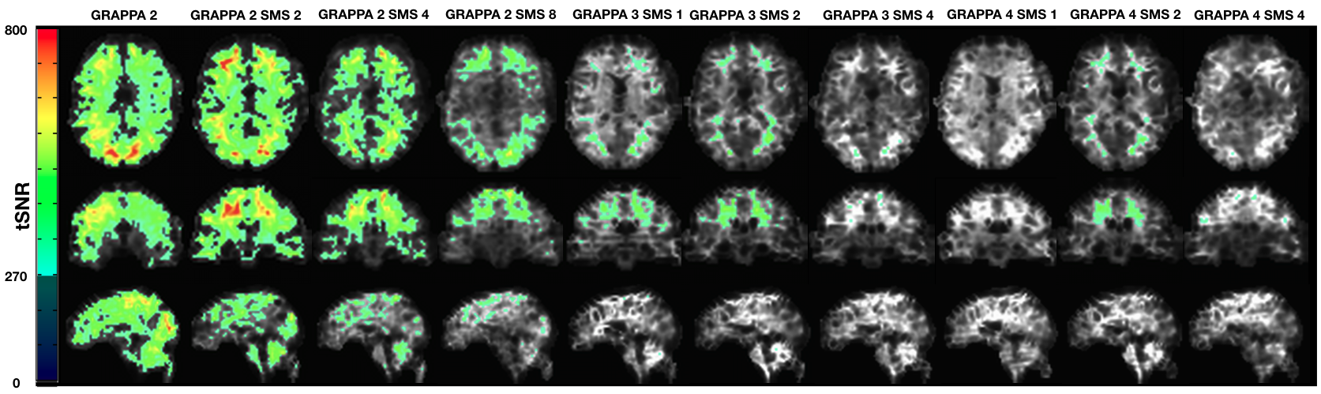

Figure 2: Voxelwise tSNR values of one subject for different GRAPPA and SMS factors. Only voxels with tSNR values greater than the mean tSNR (269.9) of the GRAPPA 2 acquisition are shown in color. Images show relative tSNR loss with increasing GRAPPA and SMS factors.

**Discussion**

**Figure 1** shows that whole-brain tSNR decreases as both GRAPPA and SMS acceleration factors increase. In **Figure 2** we see that increasing the GRAPPA factor, for the same SMS factor, produces significantly fewer voxels with tSNR values above the mean of the GRAPPA 2 acquisition. Similarly, for the same GRAPPA factor, increasing SMS above 2 significantly reduces the number of voxels with tSNR values above this threshold. Although tSNR values for SMS 1 and 2 with GRAPPA 2 are similar, especially in the central parts of the images, tSNR loss with increasing SMS is evident at the periphery. The observed decreases in tSNR reduce our ability to detect signal activation in fMRI and temporal correlations in RS-fMRI.

**Conclusions**

In this work we demonstrate using tSNR how acceleration using GRAPPA and SMS affect signal quality in RS-fMRI data. Increasing acceleration factors reduce tSNR limiting our ability to detect temporal correlations between time series data. We found that the effects of GRAPPA on tSNR were larger than the effects of SMS – for example, more voxels show acceptable tSNR using GRAPPA 2 SMS 8 than with GRAPPA 3, irrespective of SMS factor. Signal loss with higher acceleration factors are largest at the periphery. Based on our findings, we recommend that the GRAPPA factor not be increased above 2. GRAPPA2 SMS2 yield acceptable tSNR.

**References**

1. On the Definition of Signal-To-Noise Ratio and Contrast-To-Noise Ratio for fMRI Data; Marijke Welvaert, Yves Rosseel Department of Data Analysis, Ghent University, Gent, Belgium. PLOS One. 2013; 8(11): e77089. Published online 2013 November 6.

2. Evaluation of slice accelerations using multiband echo planar imaging at 3 Tesla; Junqian Xu, Steen Moeller, Edward J. Auerbach, John Strupp, Stephen M. Smith, David A. Feinberg, Essa Yacoub, & Kâmil Uğurbil. Neuroimage83(10)1016-1026(2013).